**Assignment 3: ex. 2 and 3**

**Exercise 2**

The advantage of a fully convolutional network, which only contains convolutional layers, is that it produces outputs for arbitrary input sizes. This enables a model to be trained on small images after which it can be applied to larger images such as whole slide images.1

The model that has been set up for this assignment consists of three convolution layers. The last convolutional layer gives an output of 1 x 1 x 1 for each image by using a kernel equal to the image size and by disabling padding. After this a flattening layer is incorporated which is required as this is a classification problem, so the output needs to be a single integer for each image in the batch.

Evaluation of this model with the provided validation set provides an AUC score of 0.50 and the following ROC curve. This AUC 0f 0.5 means that making random guesses will statistically perform the same as this model, which is thus not relevant. The cause of this is perhaps the convolution of the final layer, which reshapes the input to a 1 x 1 x 1. The weights of the kernel will hence have an effect on the similar place of the input and metastases are not located at a similar place in the image every time. This could explain the random behavior of this model.

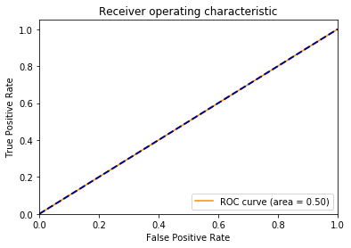

The code for this is provided in the same ZIP file with the name *Assignment3_2.py*

**Exercise 3**

Preparation of the results, which will be submitted to Kaggle, has been performed with the provided *kaggle_submission.py* file. Submitting these results provided an AUC score of 0.50. This is a identic score compared to the AUC for the validation set which was 0.50. The expectation for this behavior is explained in the exercise above.

**References**

[1] Bejnordi, B. E., Veta, M., Van Diest, P. J., Van Ginneken, B., Karssemeijer, N., Litjens, G., van der Laak, J. A. W. M. ,the CAMELYON16 Consortium, 2017. Diagnostic assessment of deep learning algorithms for detection of lymph node metastases in women with breast cancer. JAMA, 318.